ONLINE BOOK DATABASE STORE

Online book database store is a software for maintain and controlling the transactions in a library. This mini project is developed using html, css and php.

It uses wamp server to connect the html file with sql database. The project mainly focus on basic operations in a library like adding new book into the library database, searching any book by its name and name of the author. GUI (graphical user interface) or front-end is designed using the basic features of html and css.

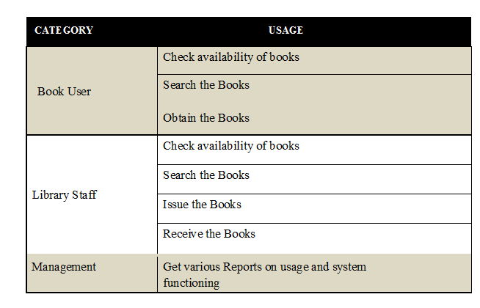

Modules of the software

* User sign up
* User login
* Search by book’s name
* Search by author name
* Inserting new book into the database.

**DATABASE DESIGN**

Database design involves constructing a suitable model. Since the design process is complicated, especially for large databases, database design is divided into three phases:

• Conceptual database design

• Logical database design

• Physical database design

The Database has been designed using MySQL comprising

* MySQL Command Prompt

**SOFTWARE USED:**

* Wamp server
* MySQL
* Notepad++

**SOFTWARE SCOPE:**

* Extensibility- The software is extensible through principles which enhance extensibility such as- hide data structures, avoid traversing multiple links and methods, avoid case statements on objects types and distinguish private and public operators.

* Re-Usability- Reusability is possible in this application as and when required. Re-usable software reduces effort in design, coding and testing. Reducing the amount of code also simplifies the understanding, which increases the likelihood that code is correct
* Understand ability- A method is understandable if a person other than the creator of the code can understand the code at any point in time in future.
* Cost Effectiveness- The application has been developed in cost effective manner for the functionalities considered in the design.

**ER-DIAGRAM**

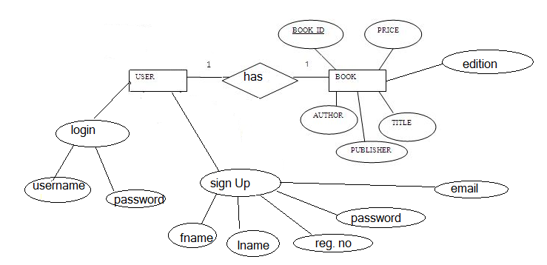

**SUBMITTED TO: SUBMITTED BY:**

**PROF.ANBARASI M. TARANG GUPTA**

**13BCE0352**

**L11-12**